March 25, 2015
EPA RUTGERS RARITAN RIVER PROJECT – Site Prioritization Methods

Methods Presented at January 15, 2015 Advisory Group Meeting:
- Rank the municipalities in order of number of data points (both sources of pollution); from highest number of sites to least number; and add up rankings in each category.
The municipalities with the highest number of sites to remediate are the highest priority.
- Same as #1, but first normalize numbers of sites by size of municipalities; instead of simple number of sites, it sets up the rankings by density of sites per square mile.

Both of these (#1 and #2) prioritize the most developed municipalities.

- Use proximity to Raritan River and other waterways. Set up a ‘waterfront buffer’ along the Raritan River and major tributaries of 1,500 feet, and mapped those sites that fall within this buffer.

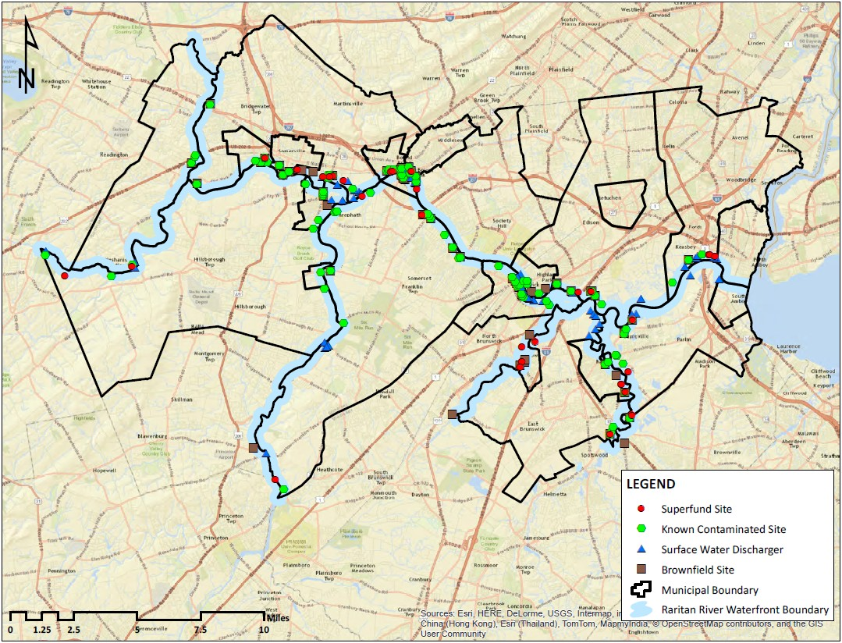

Those sites closest to waterways are a priority since they have the most potential to directly pollute the Raritan River.

- Rank sites by number of water quality violations of monitoring data.

Those sites with the most violations of an accepted standard are the priority.

- Some combination of methods #1 through #4 outlined above.

Comments on Prioritization Methods Suggested by Members of the Advisory Group:
- “I would very much like to create a weighted prioritization system that considers more than one criterion.”
- “Not a fan of option #4 at all given the age of the data. My preference is a hybrid of option #2 with a buffer overlay of Raritan River, tributaries and other environmentally sensitive areas (e.g. wetlands). It would be good to see a few maps of the hybrids.”
- “Regarding the prioritization methods, I like the # of sites/square mile strategy, which tells the intensity of pollution level relative for each municipality. I will recommend try considering adding the integrated list as another criterion which will tell people the pollution level for each subwatershed. Combining the number of polluted sites per square mile together with subwatershed integrated list might give us a better perspective to prioritize, for example, the most polluted sites per square mile within a “not meeting drinking water standard” subwatershed might be a top target for site remediation.”
- “One thought on prioritization, perhaps we look at receptors. For example, where is sensitive habitat or vulnerable populations and then see the impacts (discharges, etc.) around them. This is kind of #3, but looping in vulnerable populations or populations on local drinking water supplies (wells). I think without a scale of understanding the relevance of each data point to the other and how much of an impact each one has, prioritizing them will be a challenge (as you already know).”

