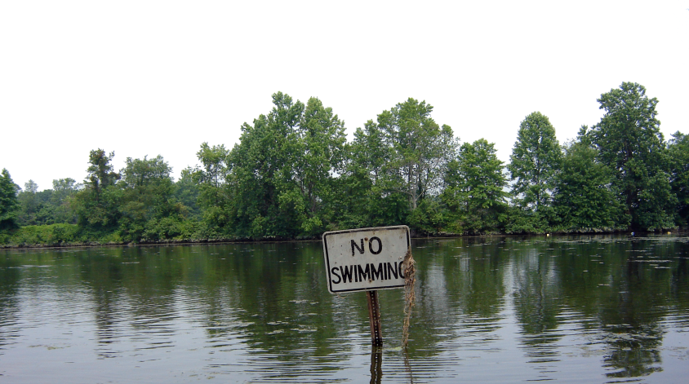
The Paraprofessional program for Watershed Restoration planning is being offered this fall for the first time to the public. The program is funded by the Dodge Foundation and is designed to be a certification course to teach individuals how to assess sites within a watershed for the disconnection of impervious cover and to examine ways to treat stormwater runoff to improve water quality. The Dodge foundation has graciously funded the course as well as a portion of staff time for individuals that work with the Rutgers Cooperative Extension Water Resources Program. Our Program staff has time to devote to individuals wanting to take the information and assessments to the next level and start to invest efforts in site evaluations of their particular interest. The volunteers that have and choose to take time to devote to assessments will be assisted with GIS information, conceptual planning, and potential design help from our staff. Ultimately, the information that is collected can be used for projects for a particular organization, a municipal impervious cover assessment, or even as part of a watershed restoration plan.
The first part of the program is in the classroom. It focuses on background information about stormwater, watershed planning, why we need these assessment efforts, etc. The second session begins outside assessing a site. This will be a led-discussion about what to be looking for when examining a site for stormwater management and disconnection. The second session will finish in a classroom.
Pdf of presentations
Session #1
Session #2 – Oct 22nd,

Resources
Link to videos
Link to Hamilton presentations
Link to Hamilton ?’s

Photos

Flyer to Share

Join the Paraprofessionals Listserv!

