New Jersey Technical Assistance Program for Combined Sewer Overflow (CSO) Communities
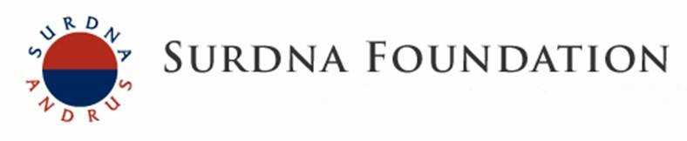

The Surdna Foundation is supporting the RCE Water Resources Program to pilot the New Jersey Technical Assistance Program for Combined Sewer Overflow (CSO) Communities. The purpose of this program is to provide guidance, technical assistance and resources to effectively implement and expand green infrastructure practices across New Jersey. The program seeks to empower municipal action teams and bring stakeholders together to address combined sewers, infrastructure needs, environmental justice, flooding, and water quality concerns. A number of obstacles continue to hinder CSO communities from pursuing green infrastructure including:
- Lack of awareness of green infrastructure funding opportunities and ability to secure funding for local green infrastructure projects
- Lack of experience with green infrastructure (planning, design, and implementation)
- Limited funding to complete up-front planning and design work needed for implementation projects

Since April 2014, this program has had a tremendous impact in tackling these barriers. Through our efforts, we have established strong relationships with communities and local partners throughout the state to pursue green infrastructure initiatives. Since 2014, the program seeks to address the following objectives:

Objective 1: Facilitate municipal action teams in CSO communities integrating them with the CSO long-term control plan
- Camden SMART (Stormwater Management and Resources Training)
- Newark DIG (Doing Infrastructure Green)
- Perth Amboy SWIM (Stormwater Infrastructure Management)
- Paterson SMART (Stormwater Management and Resources Training)
- Jersey City Green Infrastructure Subcommittee to the Environmental Commission
- Trenton City
- Gloucester City

Objective 2: Green infrastructure planning and design support
- Green Infrastructure Guidance Manual for New Jersey (available to view and download for free)
- Bayonne Green Infrastructure Feasibility Study
- Camden Green Infrastructure Feasibility Study
- East Newark Green Infrastructure Feasibility Study
- Gloucester City Green Infrastructure Feasibility Study
- Harrison Green Infrastructure Feasibility Study
- Jersey City Green Infrastructure Feasibility Study
- Newark Green Infrastructure Feasibility Study
- North Bergen Green Infrastructure Feasibility Study
- Paterson Green Infrastructure Feasibility Study
- Perth Amboy Green Infrastructure Feasibility Study
- Trenton Green Infrastructure Feasibility Study
- Union City Green Infrastructure Feasibility Study
Objective 3: Green infrastructure technical assistance
- Assisted five CSO permittees with designing 19 green infrastructure projects that have been submitted to the New Jersey Environmental Infrastructure Trust requesting over $5 million dollars for funding in 2015 and 2016.

Objective 4: Regional information sharing
- Serving on the National Urban Extension Leaders (NUEL) Steering Committee and Communications Committee
- New Jersey Technical Assistance Program for Combined Sewer Overflow (CSO) Communities eNewsletter, June 2016
- The Paterson SMART Initiative eNewsletter, April 2016
- Fixing Flooding: One Community at a Time, Innovative Solutions using Green Infrastructure Conference, February 2016
- Spanning Three Focus Areas with Green Infrastructure eNewsletter, September 2015
- Introducing Perth Amboy SWIM eNewsletter, June 2015
- Financing Opportunity for CSO Communities eNewsletter, January 2015
- Cleaning New Jersey’s Waterways eNewsletter, November 2014
- Camden’s Green Infrastructure Projects eNewsletter, September 2014
- New Jersey CSO Technical Assistance Program eNewsletter, July 2014

Project Funding Source: Surdna Foundation

For more information contact:
Christopher C. Obropta, Ph.D., P.E., 848-932-5711, obropta@envsci.rutgers.edu
Jeremiah Bergstrom, LLA, ASLA, 848-932-5708, jbergstrom@envsci.rutgers.edu
Rosana Da Silva, 848-932-6714, rdasilva@envsci.rutgers.edu

