Rain Gardens

Stormwater Management in Your Schoolyard

Overview | Grades K-8 | Grades 9-12 | How We Can Help

Overview

The Stormwater Management in Your Schoolyard program was developed by the Rutgers Cooperative Extension Water Resources Program in collaboration with the Northeast States & Caribbean Islands Regional Water Center and the New Jersey Sea Grant Consortium. The program provides educational lectures, hands-on activities, and community-level outreach for students on the topics of water quality issues and stormwater management practices such as rain gardens and rain barrels.

This program aims to provide students with an opportunity to apply their science, math, and communication skills to real-world environmental problems. Also, this program aims to increase students’ environmental awareness as they go forth and teach others in their communities about the importance of water quality and quantity. As part of this program, students are involved with the design and installation of a rain garden at their school. As part of this program, several New Jersey State Core Curriculum Content Standards for science (5.1, 5.3, and 5.4), 21st century life and careers (9.1, 9.3, and 9.4), and social studies (6.3) are addressed. This program can be tailored for grades K-8 or 9-12 and can be offered on different schedules.

Top of Page

Grades K-8

The RCE Water Resources Program has experience partnering with local organizations to deliver the Stormwater Management in Your Schoolyard program for students in grades K-8. The RCE Water Resources Program has delivered this educational program at the following schools in New Jersey:

- Birches Elementary School, Turnersville, Gloucester County
- Central Elementary School, Haddonfield, Camden County
- Ethel Jacobsen Elementary School, Surf City, Ocean County
- Hurffville Elementary School, Sewell, Gloucester County
- Lawnside Public School, Lawnside, Camden County
- Lindenwold School 4, Lindenwold, Camden County
- Sumner School, Camden, Camden County
- Sussex Avenue School of Arts and Sciences, Newark, Essex County
- Village School, Holmdel, Monmouth County
- Walnut Avenue Elementary School, Cranford, Union County
- Woods Road Elementary School, Hillsborough, Somerset County

K-8 Learning Modules

- How Are We Going to Clean Up Messy Town?

This module is designed to demonstrate to students what an average storm drain collects during a rainfall event and how the water from storm drains can impact the water quality and aquatic environments of local streams, rivers, and bays.  Curriculum: Stormwater Management in Your Backyard Rain Garden Outreach Manual – see Children’s Program section  Assessment: Stormwater Management in Your Backyard Rain Garden Outreach Manual – see Children’s Program section  Recommendations: Coming Soon! | 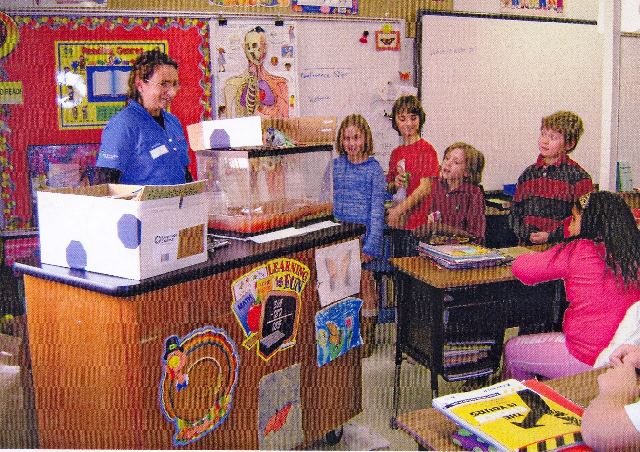
- An Introduction to Watersheds

This module is designed to introduce watersheds to students through a virtual tour of the local watershed using Google EarthTM. Students also work in small groups to identify possible pathways for stormwater runoff in their school’s watershed.  Curriculum: Coming Soon!  Assessment: Coming Soon!  Recommendations: Coming Soon! | 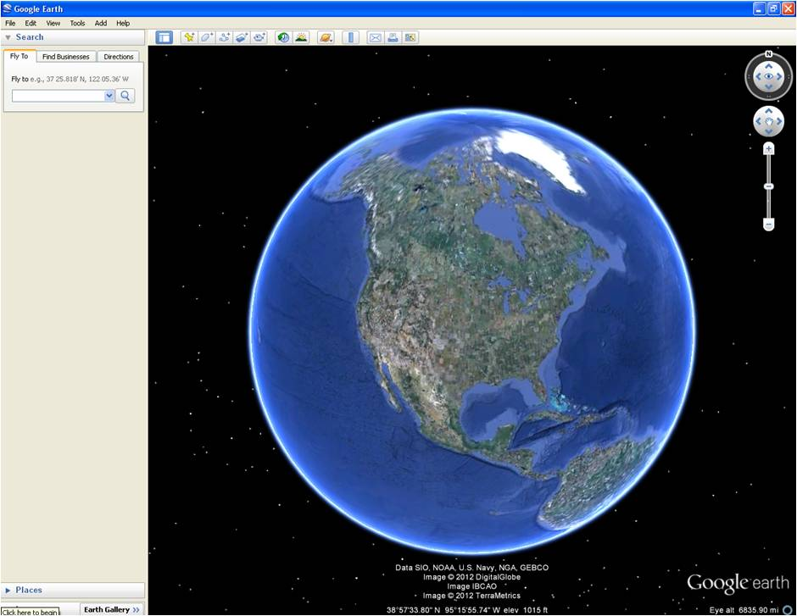
- Connecting Watersheds to Land Use

This module is designed to introduce different land uses (i.e., urban, suburban, and open space) to students through a virtual tour of the watershed and nearby areas using Google EarthTM. Historical aerial photographs of nearby areas are also shown to illustrate the changes in land use over time. Students also work in small groups to determine the land uses in their school’s watershed.

Curriculum: Coming Soon!

Assessment: Coming Soon!

Recommendations: Coming Soon!
- Stormwater Runoff and Nonpoint Source Pollution in Watersheds

This module is designed to demonstrate to students what an average storm drain collects during a rainfall event and how the water from storm drains can impact the water quality and aquatic environments of local streams, rivers, and bays. Students also work in small groups to identify possible nonpoint source pollutants found in specific areas of their school’s watershed. The students then determine the solutions to the nonpoint source pollution that they identified in their section of their school’s watershed. Rain gardens are introduced to the students as a way of capturing nonpoint source pollution and managing stormwater runoff.  Curriculum: Coming Soon!  Assessment: Coming Soon!  Recommendations: Coming Soon! | 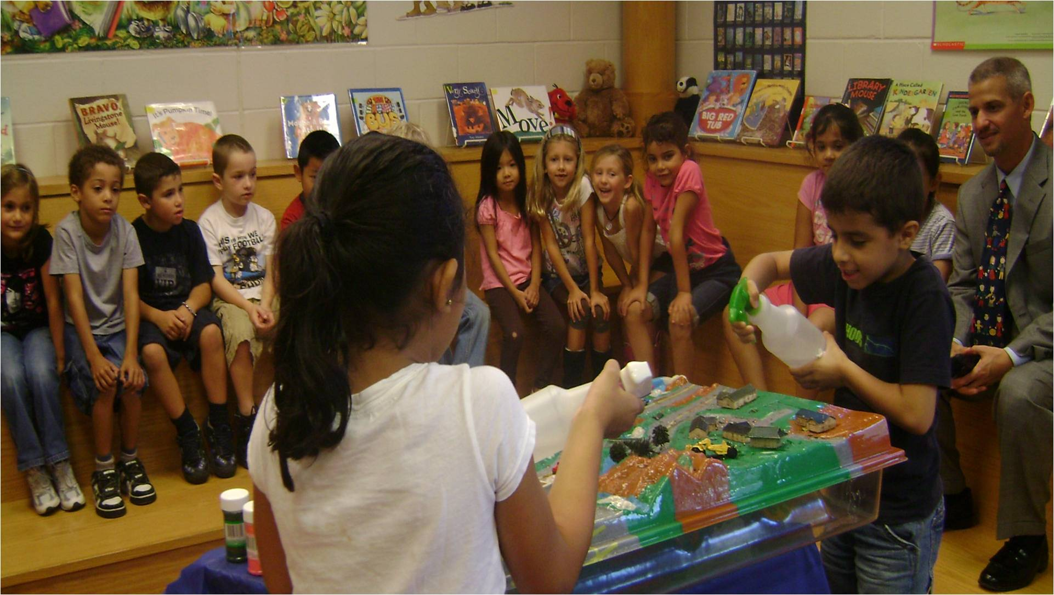
- Rain Garden Soil Considerations

This module is designed to demonstrate to students the different types of soil texture and water infiltration through soil. Students also work in small groups to investigate their schoolyard’s soil type. A discussion of why rain gardens require a certain type of soil is conducted.

Curriculum: Coming Soon!

Assessment: Coming Soon!

Recommendations: Coming Soon!
- Rain Garden Native Plant Considerations

This module is designed to demonstrate to students what native plants are and also explain what makes a healthy garden. A discussion of how different plants prefer different zones of the rain garden is conducted.

Curriculum: Coming Soon!

Assessment: Coming Soon!

Recommendations: Coming Soon!
- Rain Garden Design Exercises

This module is designed to explain to students how to design a rain garden. Students also work in small groups to prepare a design for their school’s rain garden.

Curriculum: Coming Soon!

Assessment: Coming Soon!

Recommendations: Coming Soon!
- Rain Garden In-Class Presentations

This module is designed for students to finalize their rain garden designs and to present their designs with their classmates.

Curriculum: Coming Soon!

Assessment: Coming Soon!

Recommendations: Coming Soon!
- Rain Garden Installation and Maintenance

This module is designed to provide students with an overview of how rain gardens are installed and maintained. Students also work in small groups to plant their school’s rain garden and to determine how to take care of their school’s rain garden.  Curriculum: Coming Soon!  Assessment: Coming Soon!  Recommendations: Coming Soon! | 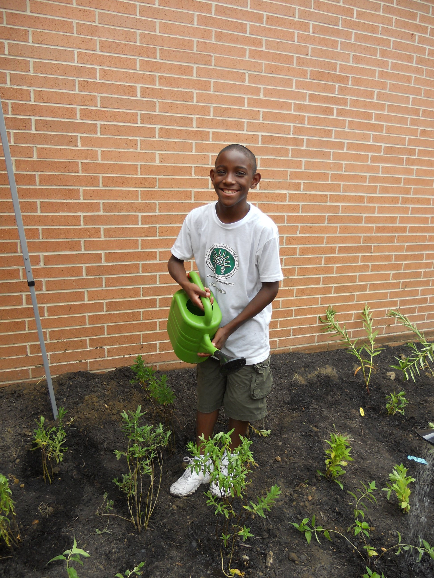
- Rain Garden Community Presentations

This module is designed to provide students with an opportunity to teach their local community about stormwater management and rain gardens. Video technology and/or poster presentations can be used to deliver their message.  Curriculum: Coming Soon!  Assessment: Coming Soon!  Recommendations: Coming Soon! | 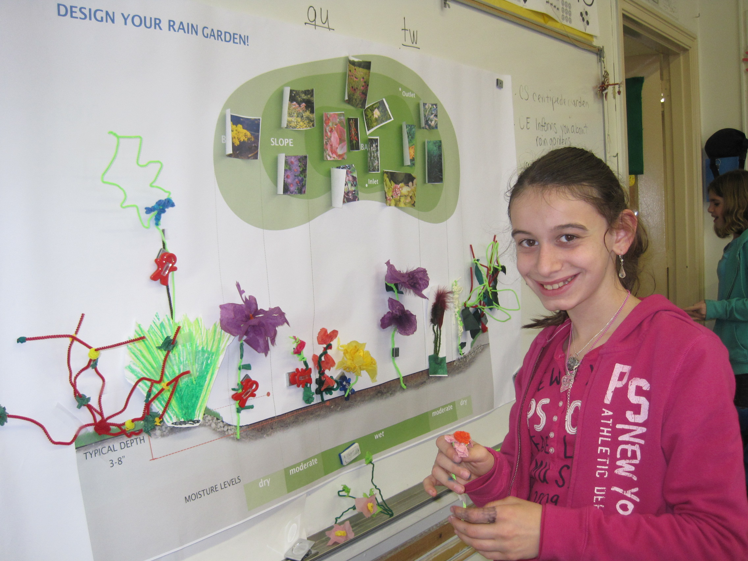
- Rain Garden Planting

This module is designed to provide students with an overview of how rain gardens are used to capture nonpoint source pollution and managing stormwater runoff. Students also work in small groups to plant their school’s rain garden.  Curriculum: Coming Soon!  Assessment: Coming Soon!  Recommendations: Coming Soon! | 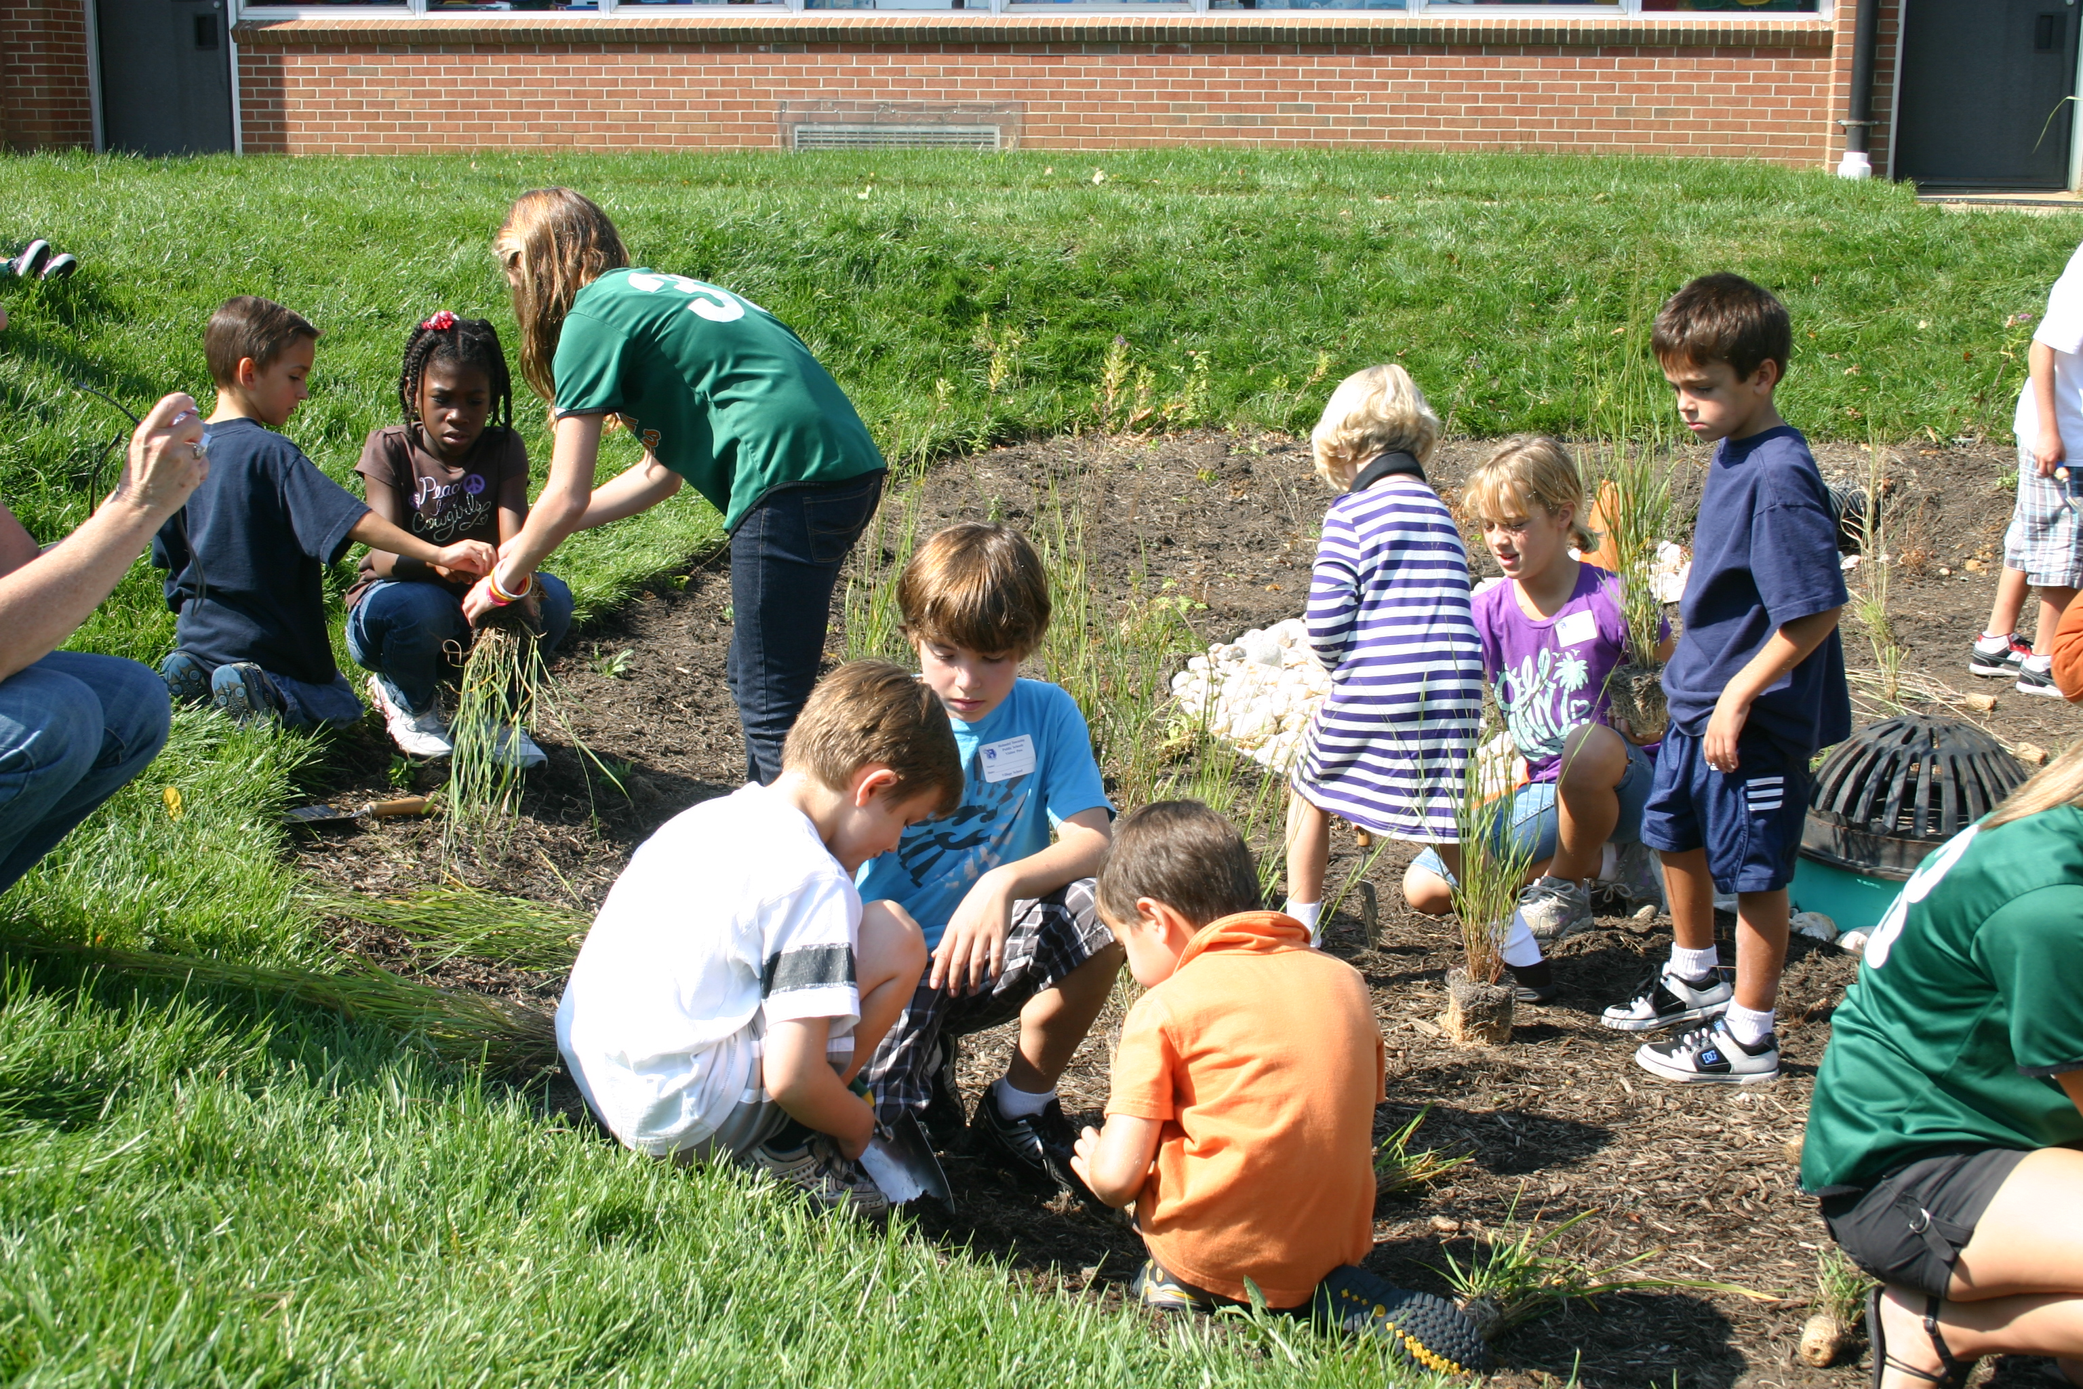
- Rain Barrel Art

This module is designed to demonstrate to students with an overview of how rain barrels are used to collect rainwater and manage stormwater runoff. Students also work in small groups to beautify their school’s rain barrel.  Curriculum: Coming Soon!  Assessment: Coming Soon!  Recommendations: Coming Soon! | 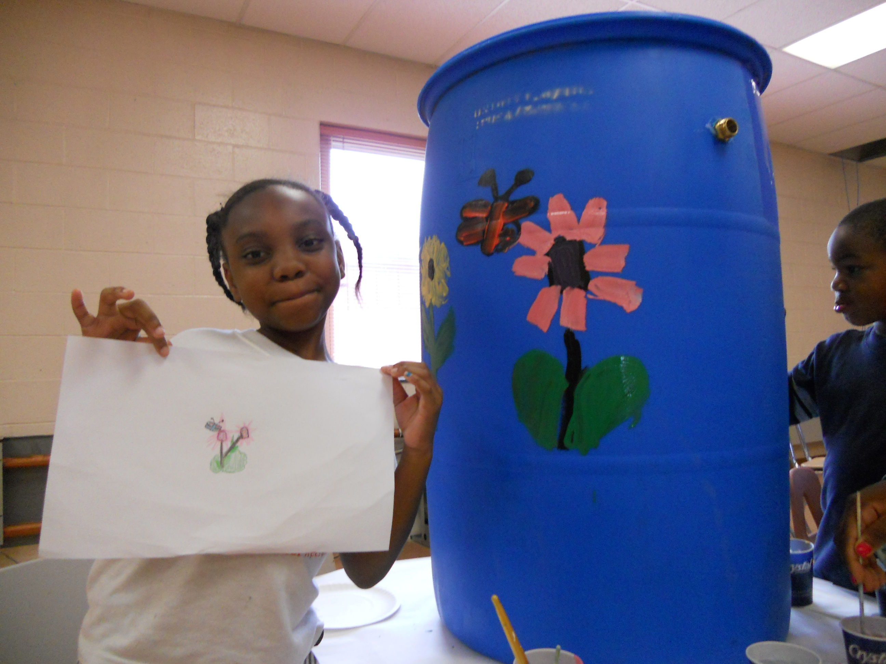
- Rain Garden Daffodil Planting

This module is designed to provide students with an overview of how rain gardens are used to capture nonpoint source pollution and managing stormwater runoff. Students also work in small groups to plant their school’s rain garden with daffodils that will bloom in early spring.  Curriculum: Coming Soon!  Assessment: Coming Soon!  Recommendations: Coming Soon! | 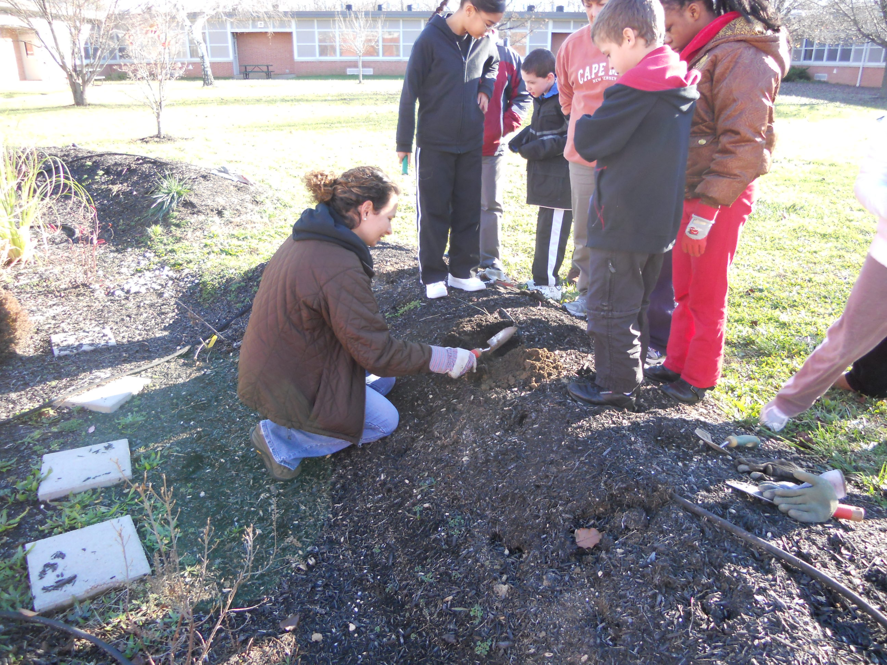

Top of Page

Grades 9-12

The RCE Water Resources Program has experience partnering with local organizations to deliver the Stormwater Management in Your Schoolyard program for students in grades 9-12. The RCE Water Resources Program has delivered this educational program at the following schools in New Jersey:

- Arthur L. Johnson High School, Clark, Union County
- Haddonfield Memorial High School, Haddonfield, Camden County
- Lindenwold High School, Lindenwold, Camden County
- Timber Creek High School, Sicklerville, Camden County
- Union County Vocational Technical School, Scotch Plains, Union County

9-12 Learning Modules

- Stormwater and Rain Garden Site Selection

This module is designed to demonstrate to students what an average storm drain collects during a rainfall event and how the water from storm drains can impact the water quality and aquatic environments of local streams, rivers, and bays. Rain gardens are introduced to the students as a way of capturing nonpoint source pollution and managing stormwater runoff. An in-depth discussion of how a rain garden can be designed for their school is provided. If ample time, students also work in small groups to prepare a design for their school’s rain garden.

Curriculum: Coming Soon!

Assessment: Coming Soon!

Recommendations: Coming Soon!
- Rain Garden Installation

This module is designed to provide students with an overview of how rain gardens are used to capture nonpoint source pollution and managing stormwater runoff. Students also work in small groups to plant their school’s rain garden.  Curriculum: [PDF] [MS Word]  Assessment: Embedded in the curriculum  Recommendations: Coming Soon! | 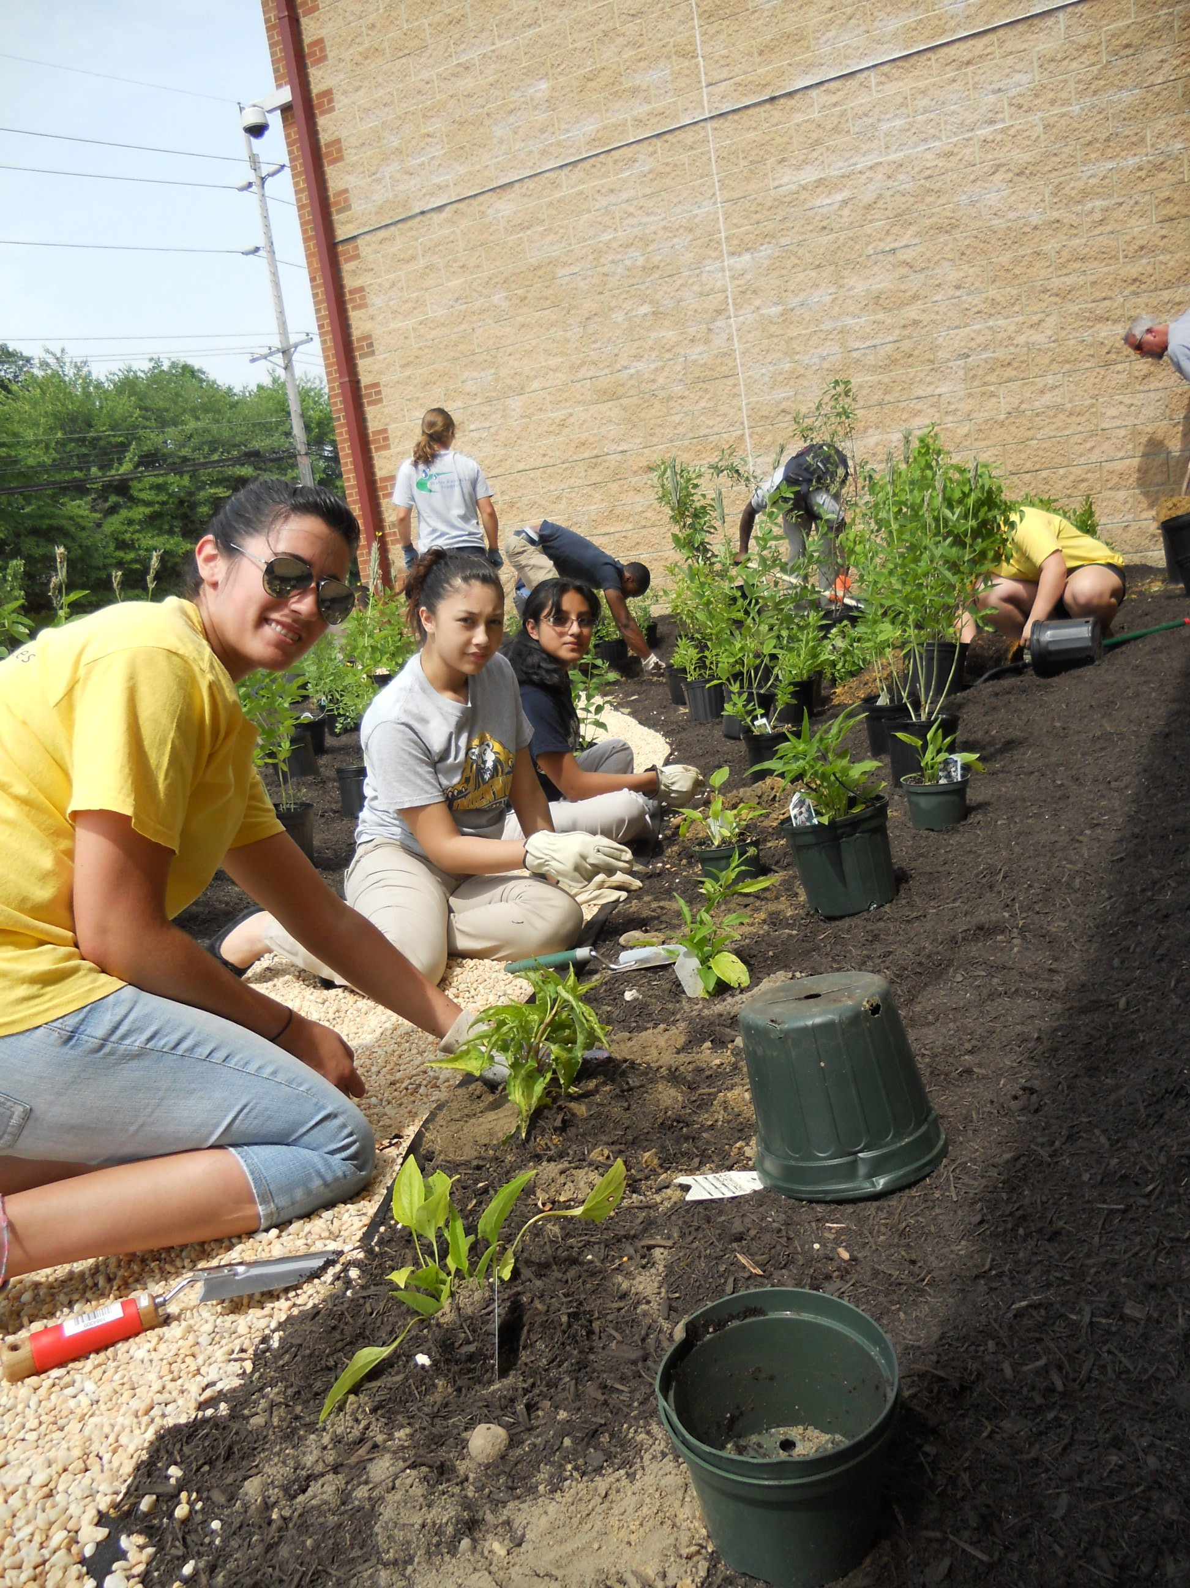
- Why Rain Gardens?

This module is designed to provide students with an overview of how rain gardens are used to capture nonpoint source pollution and managing stormwater runoff. Students are then given a tour of their school’s rain garden and determine how to take care of their school’s rain garden.  Curriculum: Coming Soon!  Assessment: Coming Soon!  Recommendations: Coming Soon! | 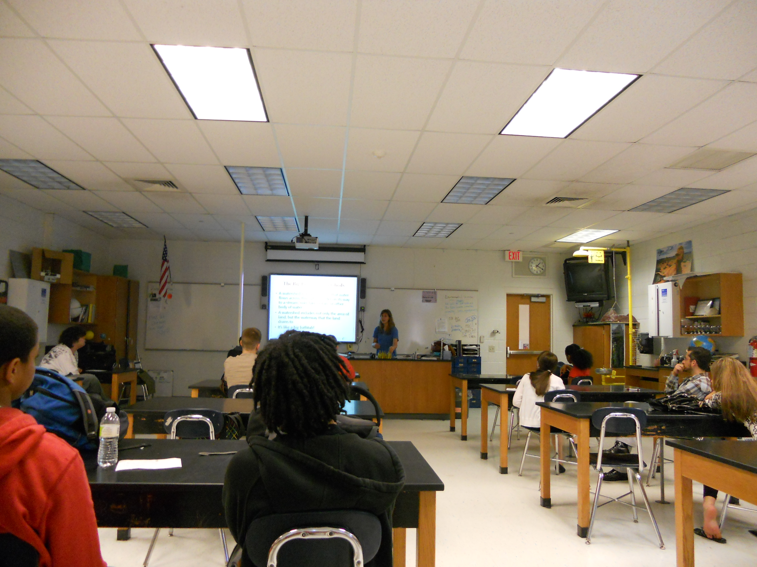

Top of Page

How We Can Help

Every school is unique in its need for stormwater management, so each school’s Stormwater Management in Your Schoolyard program can be delivered in a variety of ways. The RCE Water Resources Program staff works directly with the teachers to include the appropriate content as well as assessment tools.

If you would like more information about how to bring this program to your own learning community, please contact:

Amy C. Boyajian
Program Associate
RCE Water Resources Program
(732) 932-9800 ext. 6164
boyajian@envsci.rutgers.edu

Top of Page

