WHO IS ELIGIBLE FOR FUNDING?

Eligible applicants for funding through the Upper Salem River Watershed Agricultural Mini-Grant Program are:
- Properties located within the Upper Salem River Watershed (see Target Area below)
- Land currently in agricultural usage, such as cropland, nursery operations, pasture, sod farms, and other agricultural land on which agricultural products, livestock or forest-related products are produced

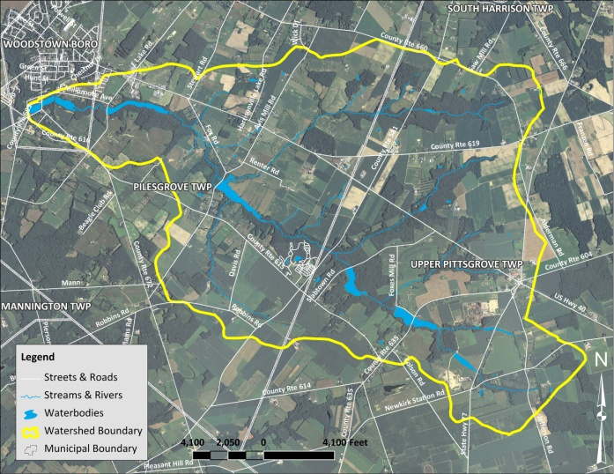
Target area (in yellow) for the Upper Salem River Watershed Agricultural Mini-Grant Program

Funding for this program is provided by the New Jersey Department of Environmental Protection through the 319(h) Grants for Nonpoint Source Pollution Control.
ABOUT THE PROGRAM

The Upper Salem River Watershed Agricultural Mini-Grant Program provides funding for producers to implement agricultural management practices (AMPs) that improve water quality in the Upper Salem River and its tributaries or to promote water conservation and efficiency.

The Mini-Grant Program provides funding to either complement United States Department of Agriculture Farm Bill programs (NRCS, FSA) or sole-source of funding for applicable AMPs.

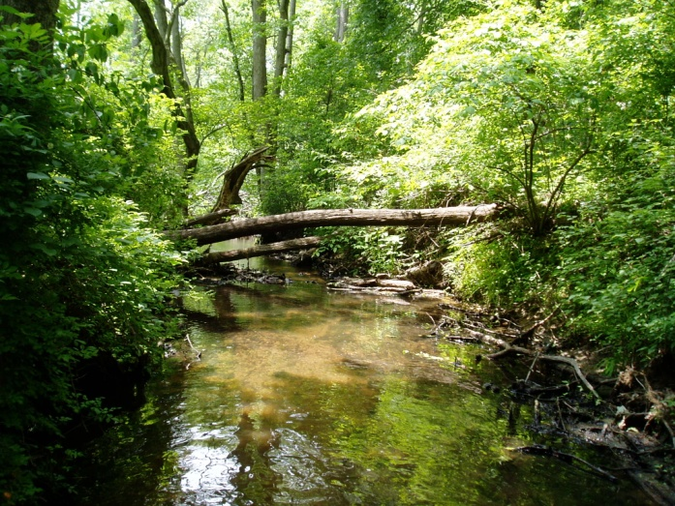

The Mini-Grant Program will:
- Encourage the use of conservation practices which reduce the impact of agricultural nonpoint source pollution
- Provide cost-share assistance as an incentive to implement conservation practices
- Improve producer-based stewardship of land and water resources

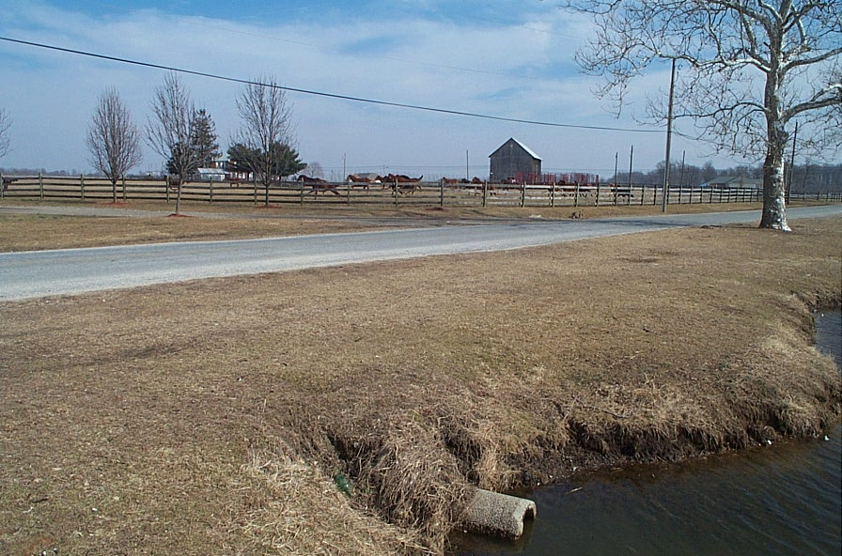

Examples of conservation practices that can receive funding include:
- filter strips and stream buffers
- grassed waterways
- soil erosion prevention
- irrigation systems
- tailwater recovery
- cover crops
- nutrient management plans and actions
- pest management planning and implementation
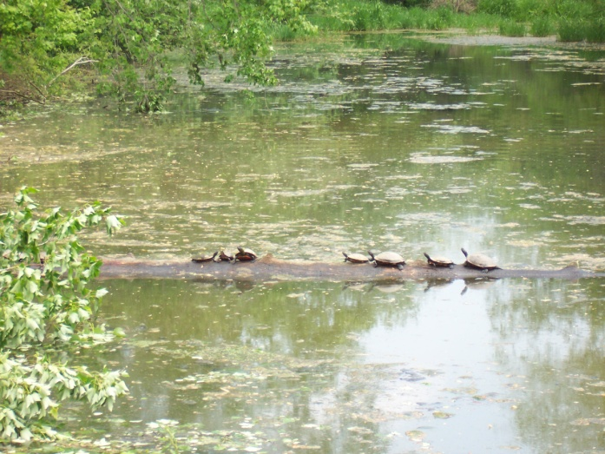

Steps to Apply for a Mini-Grant:
- Contact one of the members of the project partnership (see contact information below) to discuss your project and for assistance in applying to the Mini-Grant Program.
- Obtain a copy of the application from http://water.rutgers.edu/ or by contacting the project coordinator (see contact information below).
- Fill out the application and submit the completed application by email to evrard@rci.rutgers.edu or mail a hardcopy to:
Upper Salem River Watershed
Agricultural Mini-Grant Program
ATTN: Lisa Galloway Evrard
Rutgers Cooperative Extension
Water Resources Program
14 College Farm Road
New Brunswick, NJ 08901-8551

If you have any questions, please contact any of the following:
- Sal Mangiafico:
mangiafico@njaes.rutgers.edu or at
(856) 769-0090
- Dave Lee:
dlee@njaes.rutgers.edu or at
(856) 769-0090
- Lisa Galloway Evrard:
evrard@rci.rutgers.edu or at
(848) 932-6726
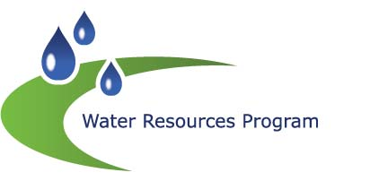
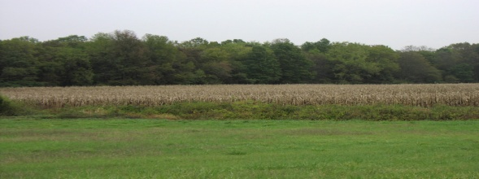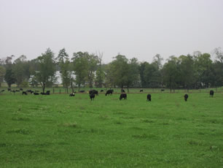
UPPER SALEM RIVER WATERSHED
AGRICULTURAL MINI-GRANT PROGRAM

HOW WE CAN HELP?
If you would like more information about how to participate in the Upper Salem River Watershed Agricultural Mini-Grant Program, please contact:

Lisa Galloway Evrard
Senior Program Coordinator
Rutgers Cooperative Extension
Water Resources Program
(848) 932-6726
evrard@rci.rutgers.edu
http://water.rutgers.edu

Project Partners & Collaborators:
Rutgers Cooperative Extension
Water Resources Program
Rutgers Cooperative Extension of
Salem County
New Jersey Department of
Environmental Protection
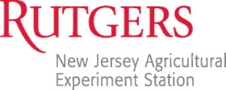
Christopher C. Obropta, Ph.D., P.E.
Associate Extension Specialist
(848) 932-5711
obropta@envsci.rutgers.edu
http://water.rutgers.edu

